**Emotional Awareness Dashboard – High Fidelity Prototype**

Will Murrell

2022

**Overview**

The emotional awareness dashboard is a website designed to be used by students and teachers. The students would use it to write a weekly blog and view the comments that their teacher has left them for previous blogs. Before the blogs are made available to the teachers, a back-end process will annotate each sentence with an emotion and learning experience. The teachers would use it to view student’s blogs, with the added annotations, and be able to add comments for the student. The teacher is also able to view a normalized average of the sentence annotations in the form of horizontal bar graphs (Figure ?.). These graphs are per week and change in scope from just the individual student to every student in their team, and then every student in their course.

**Teachers Dashboard**

**Home Page**

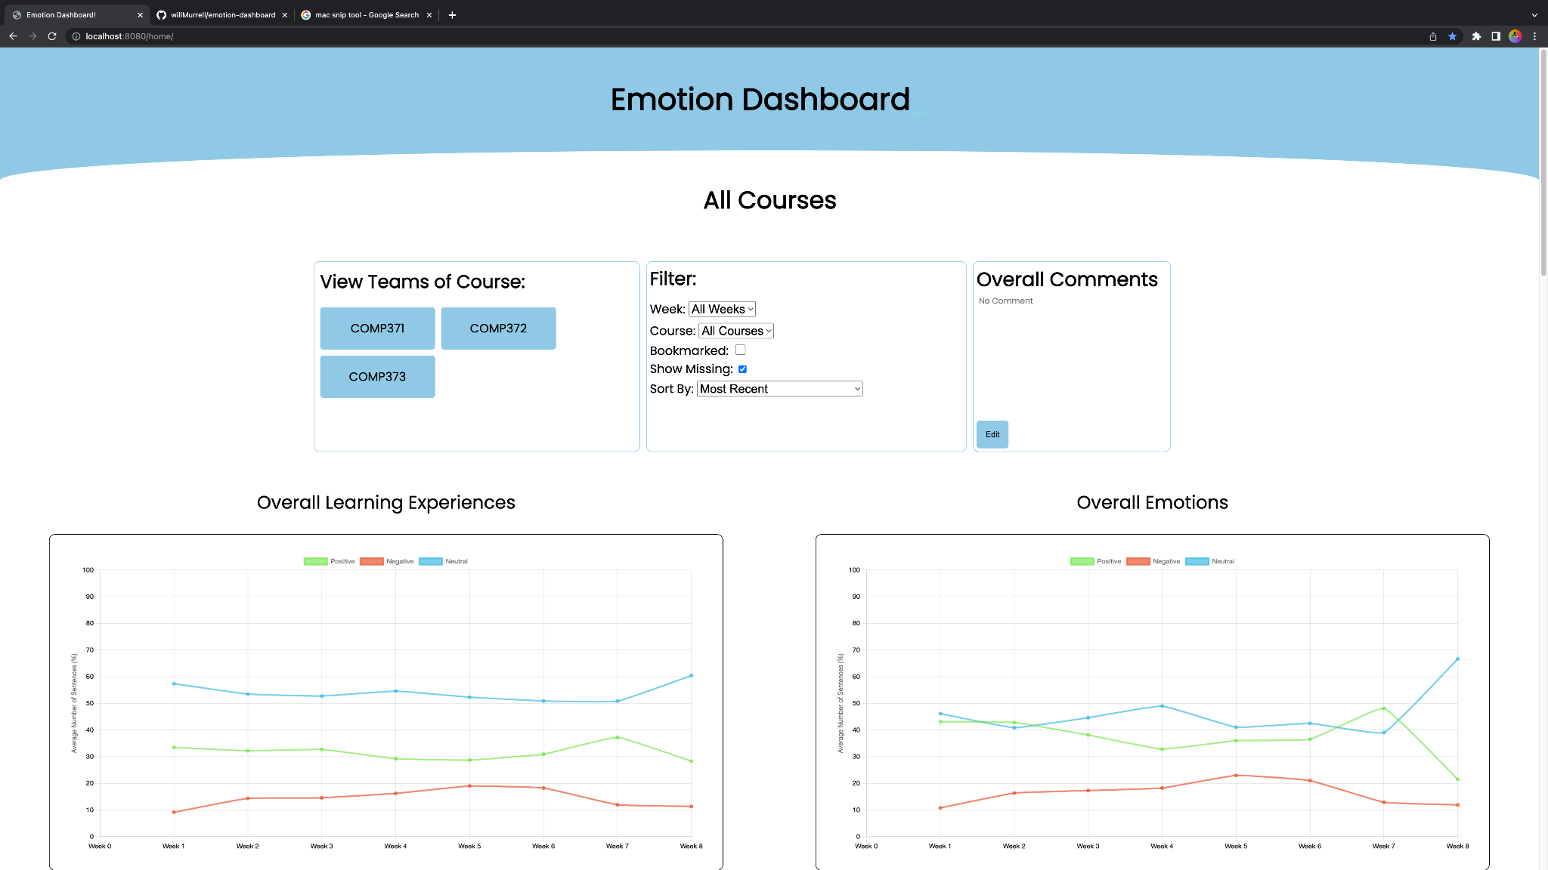

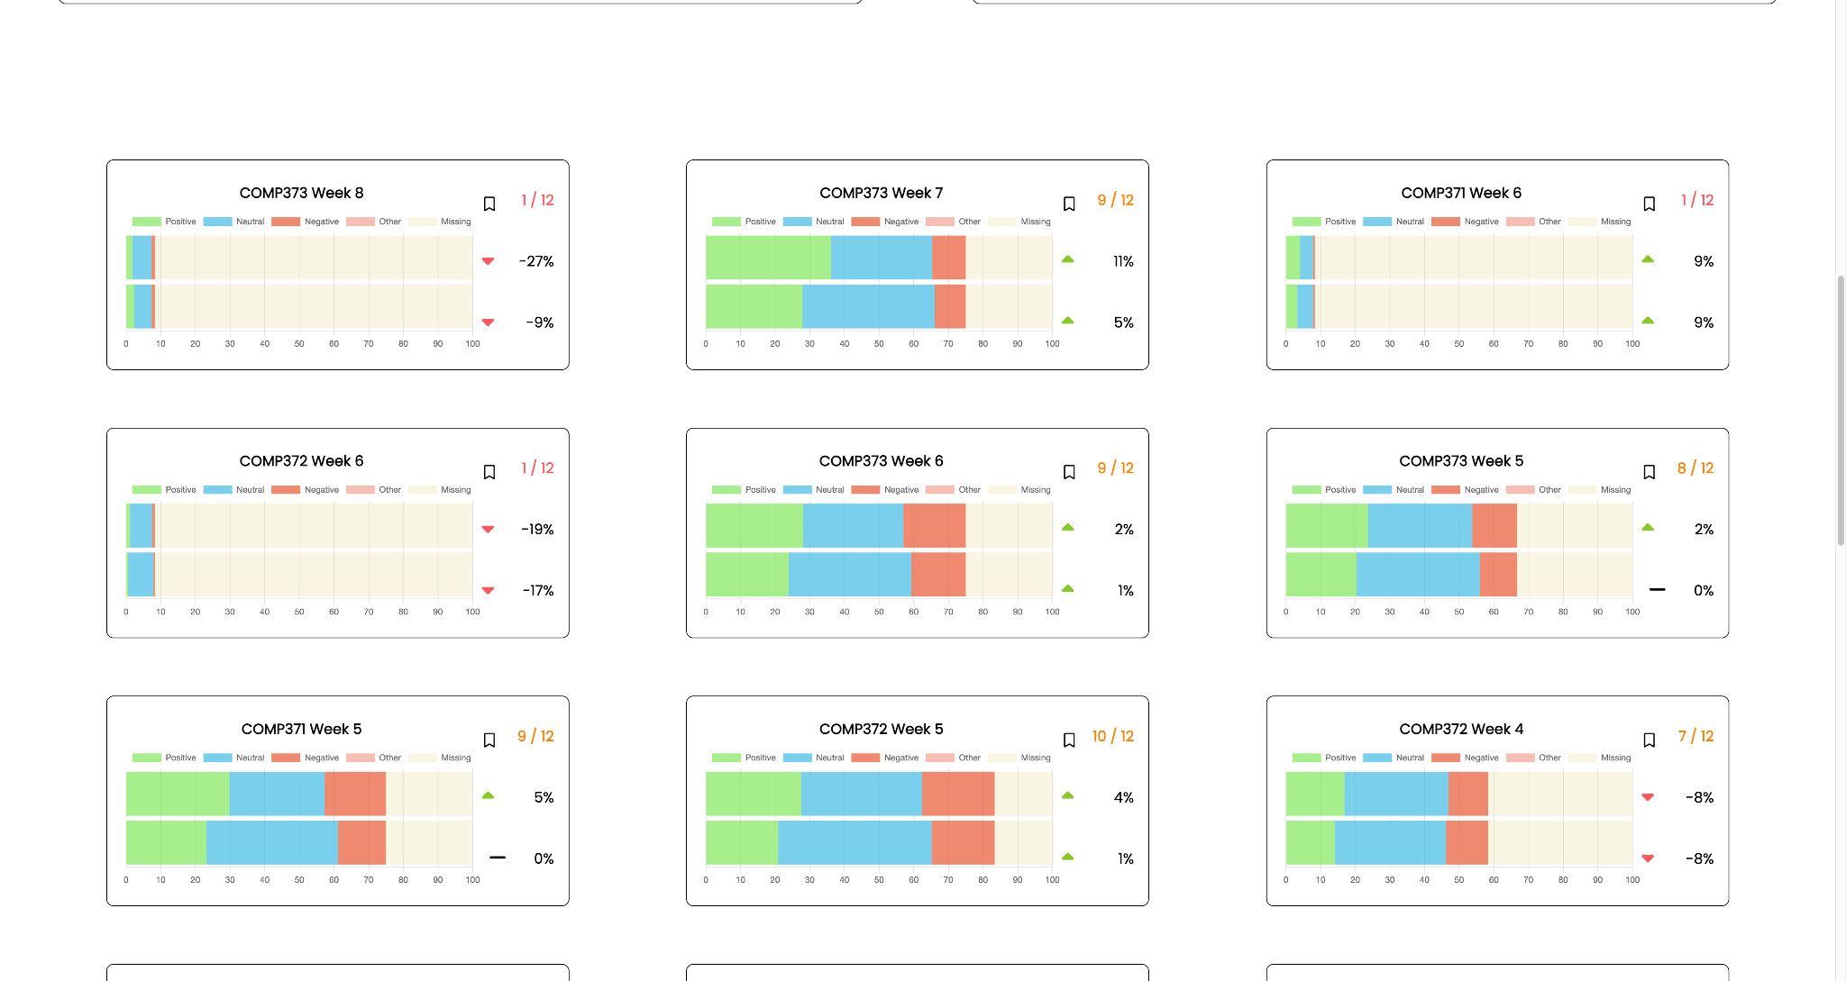

This is the page the teacher will see after a login page. The home page shows the “course-view” page. That is, it will show us the graphs of all courses registered to this teacher, and will allow for navigation into a specific course. The filter changes which graphs are shown. This allows the teacher to view only a specific week or specific course. By default, it is sorted to show the most recent graphs, but can be changed to find which groups are most/least in need of help. Next is the ”Overall Comments”. Each page has a similar section. Comments written here do NOT get sent to the student and are just for the teachers personal notes. The learning experiences and emotions line graphs show the same information in the graphs below them, in a fast, easy to look at way. These graphs will change if the “course” option is changed in the filter. Below them are all the graphs. These show a more detailed report of each course over each week.

**

These graphs are on the course-, team-, and student-wide pages. For the graphs that contain more than one student, each student’s entry is normalized so they take up an equal proportion of the graph. The title tells us which course and week the graph is displaying the information from.Each bar is split into positive, neutral, negative, other and missing. Hovering over a section of the bar graph will tell you what the whole bar is showing (“Emotions”), what that section of the bar is for (“Neutral”) and what percent of the total bar it is (“29.28%”). The top bar shows the normalized average of the emotions found in all student blogs for that course, in that week. The bottom bar is the same, just for the learning experiences found. The bookmark icon can be clicked to bookmark this graph. This means it will show up when the bookmark filter is clicked. The 9/12 refers to how many students submitted blogs for this week. Hovering over it will show which students did and did not submit blogs. Similar information can be found by looking at the “missing” section of the graphs. 25% of the graph is “missing” as is 25% of the students’ blogs. Beneath the missing students section are how much, as a percentage, has the graph changed from the previous week. This gives an indication of how this course is doing compared to last week. The arrows can be up-pointing green (positive change), black flat lines (no change) or down-pointing red (negative change)

**“Team-view” page**

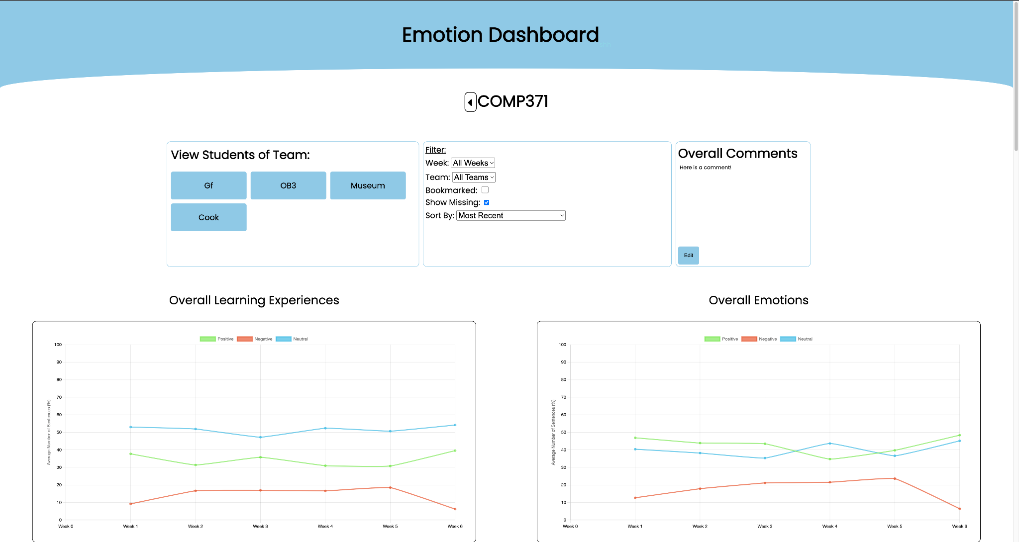

After clicking on one of the courses at the top of the home page, you will be taken to that courses “team-view” page. This page shows the graphs of all the teams within that course. The filter and overall comments section are functionally the same as on the home page, other than that you now sort by “team”, rather than “course” and the overall comments section will display whatever comment the teacher has written for this section. The line graphs now show this course’s overall values and again will change if the filter is changed.

**“Student-view” page**

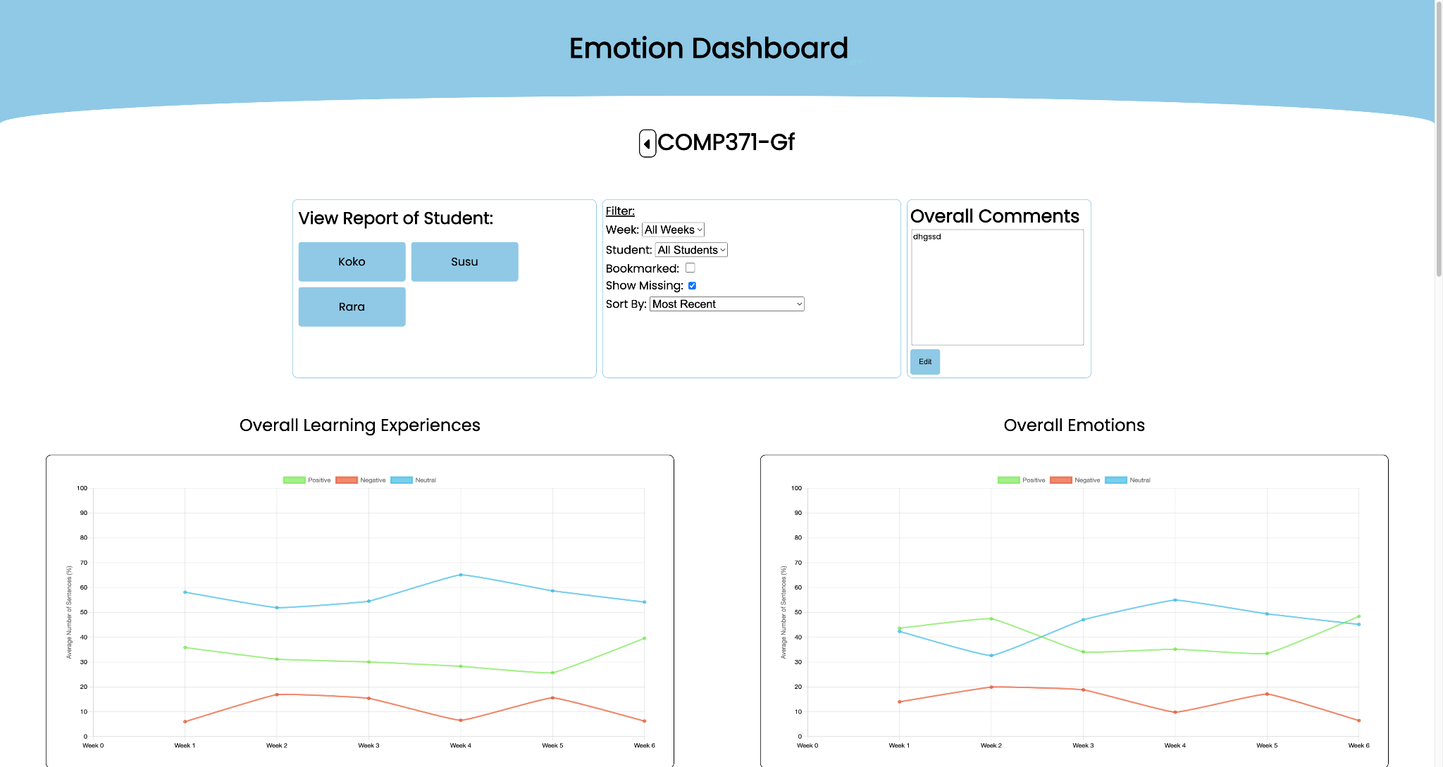

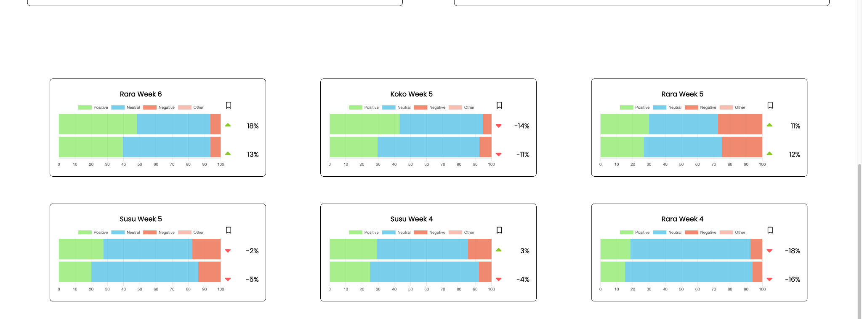

Once again very similar to the previous page, and again navigated to by selecting one of the teams towards the top of the page. This page will now show all the graphs of the students of that team. The filter, overall comments and line graphs again change to fit this “student-view” scope

**Individual Student Report Page**

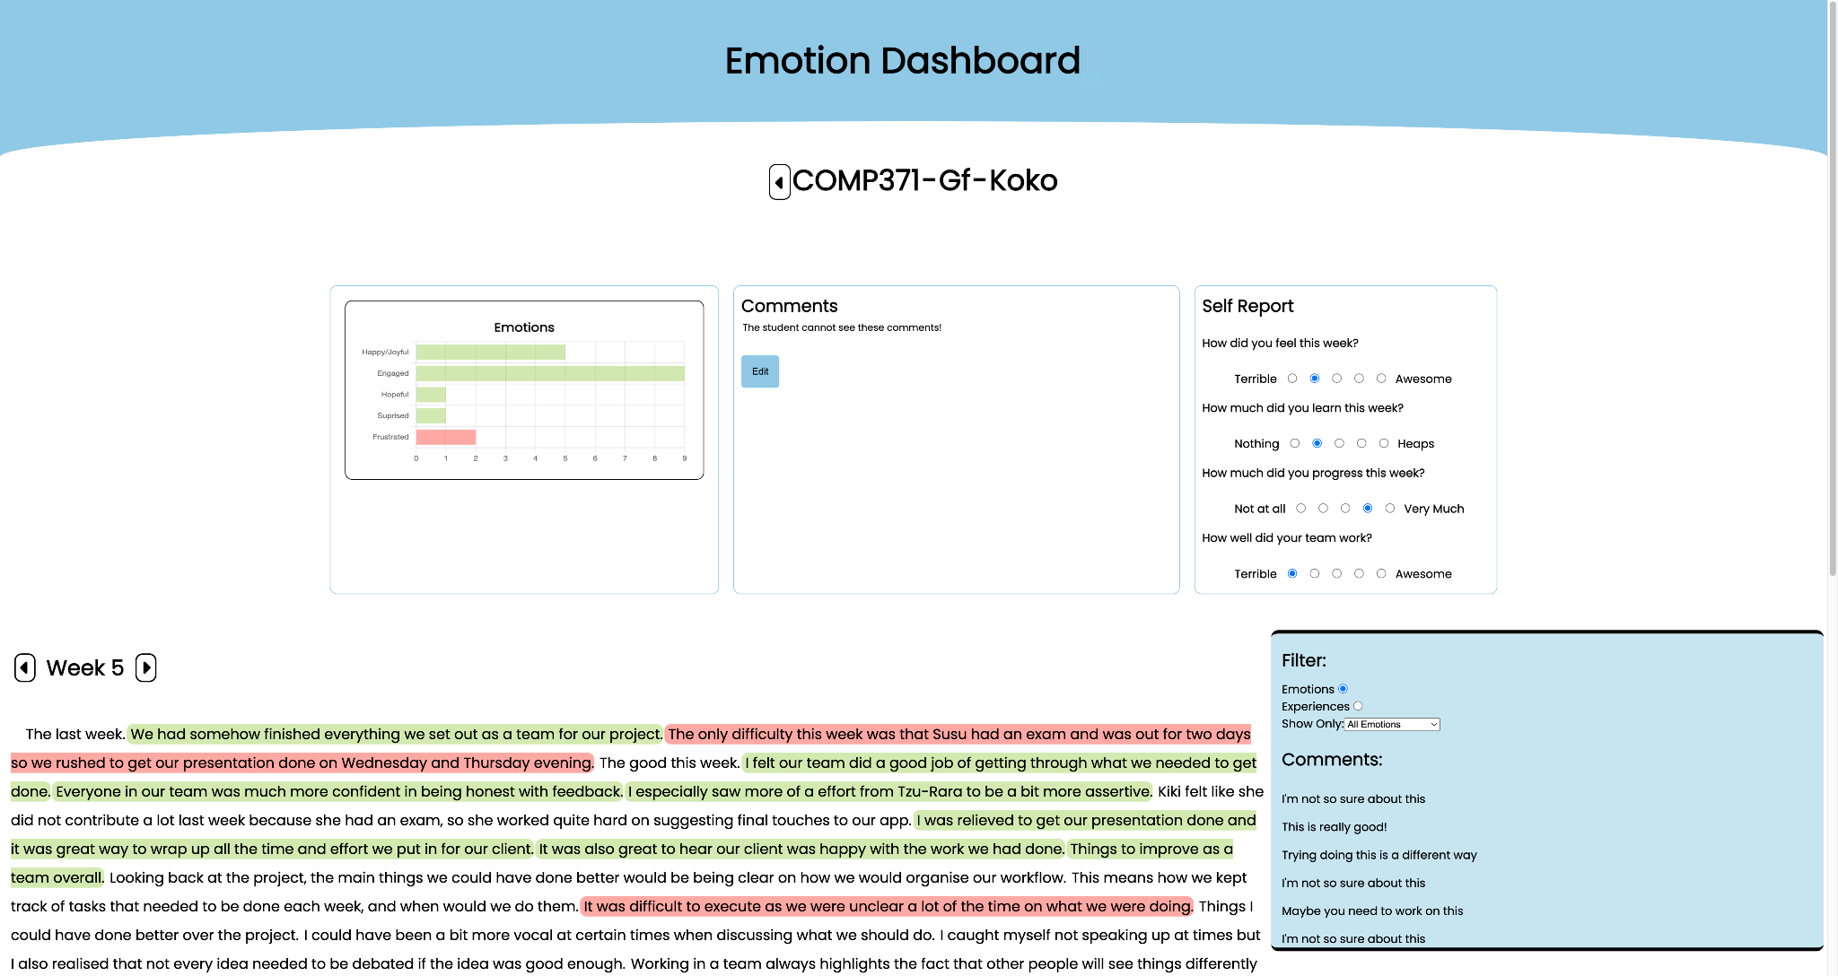

From the “student-view”, clicking on one of the students in the navigation section will take you to that student’s “report page”. Note that a single student will have a unique “report page” for each course that they are in. The top section contains a bar graph, overall comments, and self-report information. The bar graph (by default) shows us which emotions are present and their frequency in the selected week. The overall comments again are not sent to the student and are just for the teacher. The self-report information will show the student’s self-report results from the selected week. Below them are the report area and the sidebar.

The report area title is the current week selected, which can be changed by pressing the arrows to the left and right of the title. Beneath the title is the report written by that student for the selected week. Some sentences will have different highlight colours. These are based on (by default) the emotions that have been associated with that sentence. A green highlight means there are at least one positive emotion, and no negative emotions being portrayed in that sentence. The orange/yellow highlight means that there is at least one positive and at least one negative emotion attributed to that sentence. Red means that there is at least one negative emotion, and no positive emotions attributed to the sentence. Clicking on a sentence will add a black outline to show the bounds of the sentence. Hovering over a sentence will show specifically which emotions are attributed. Depending on whether there is a comment associated with the sentence or not, the comment will be selected in the side bar, or a text area will appear, allowing you to write a new comment for that sentence. The side bar contains a filter and the comments section. The filter allows you to switch between viewing emotions and viewing learning experiences. It will change the sentence highlights, hovers, and the bar graph at the top. The “show only” part will allow you to have specific emotions/experience show up in the highlights. There is also an option for all positive and all negative emotions/experiences. Beneath the filter are the comments. These are written by the teacher and WILL be made available for the students to see. Selecting a comment will underline it, and outline the sentence that it refers to. Double clicking will allow for the comments to be edited or deleted.

**Students Dashboard**

**Home page**

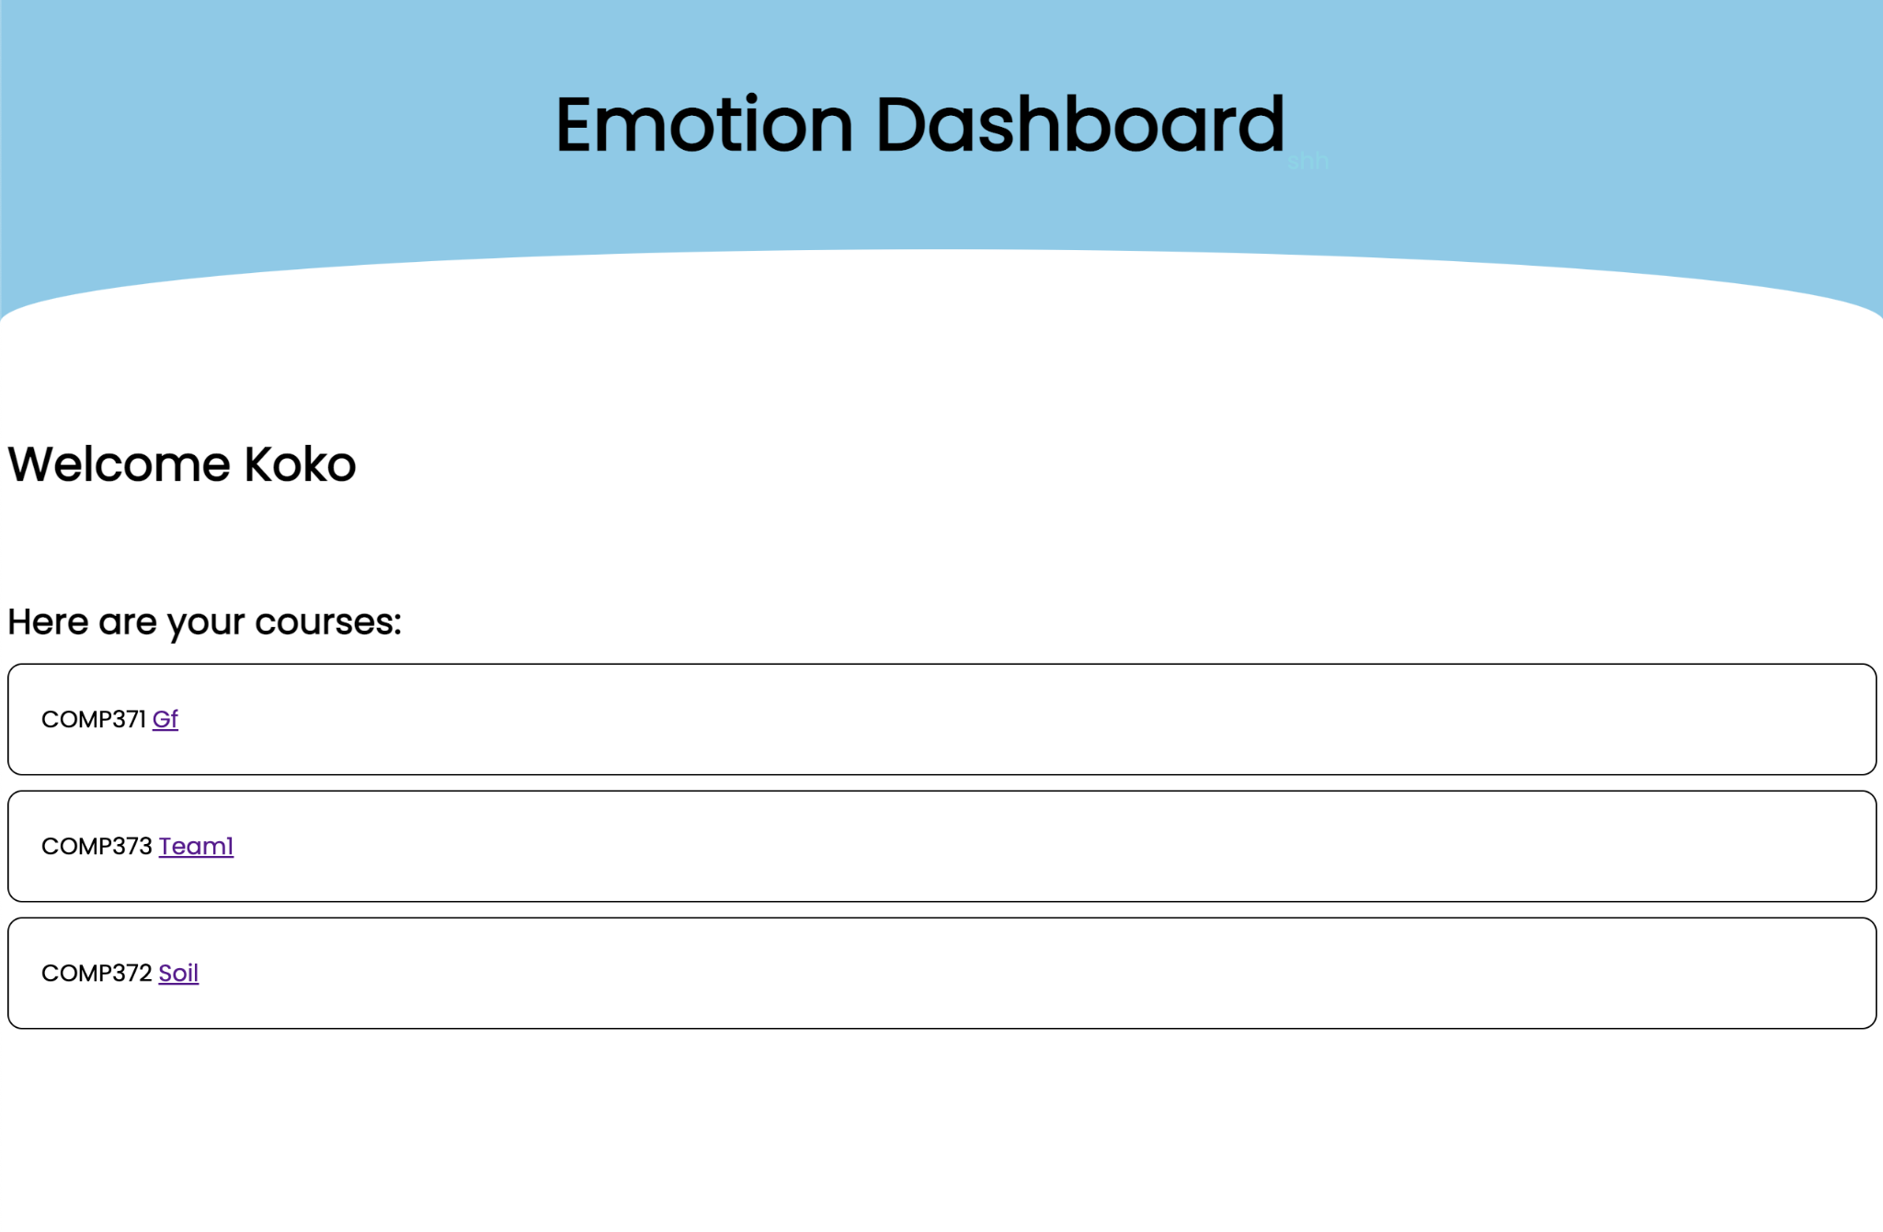

This is the page the student will see after logging in. It shows them the courses/teams they are part of. Clicking on the team will navigate them to their blog page for that course.

**Blog Page**

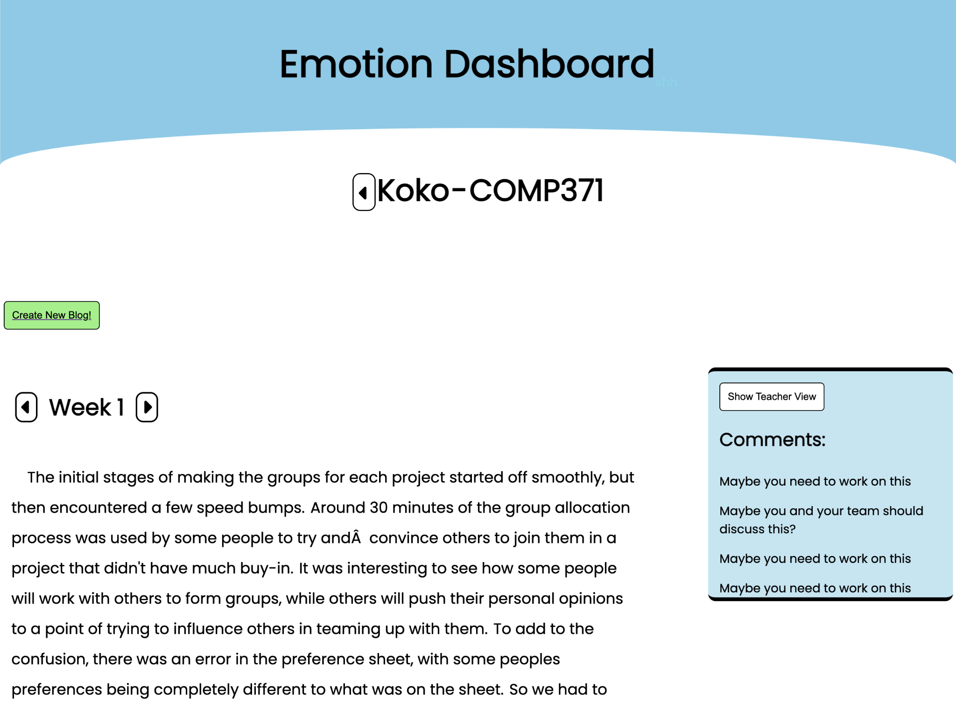

The blog page is where students can view previous blogs, along with the comments for them, and also write new blogs. It shares many of the same features as the individual student report page from the teachers dashboard. However it does not include the bar graph and all the overlays are hidden by default. In order to be transparent about the data collected from the students there is a button (“Show Teacher View”) that will display the overlays that the teacher sees. There is also (by default) a “Create New Blog” button. This will take the student to the “New Blog” page. If this student already has a draft saved for this weeks blog then the button will be orange and say “Edit Blog Draft”

**New Blog Page**

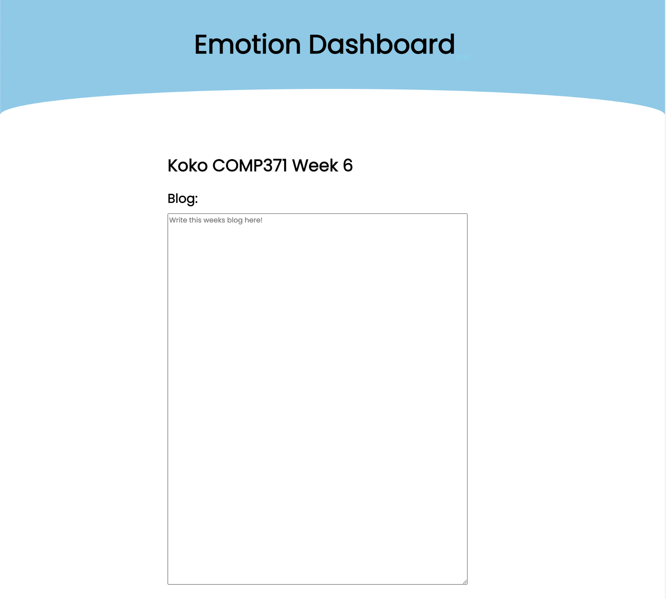

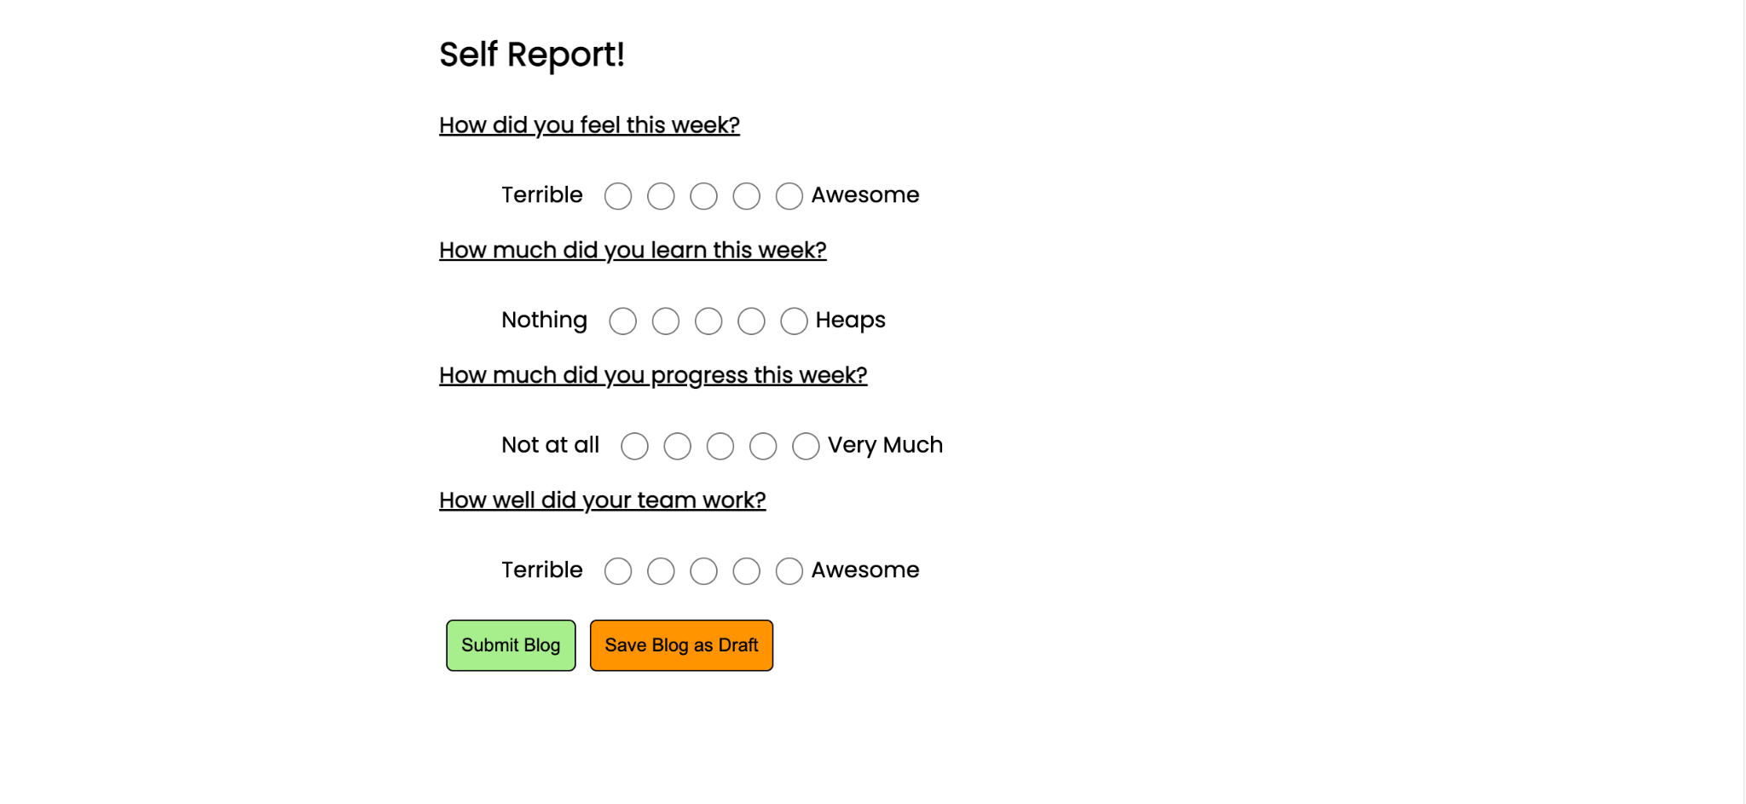

The New Blog Page starts with the title, telling the student which course and week this blog is for. Beneath that is the text area where the students are to write their blog. Next is the self-report section. This section lets the student answer four questions on a 5 point Likert scale. The student can then submit the blog or save the blog as a draft. To submit the blog, all sections (the blog and all questions) must have been filled out. Saving as a draft allows for sections to be missing.